I installed virtual box and then installed windows 10 in it

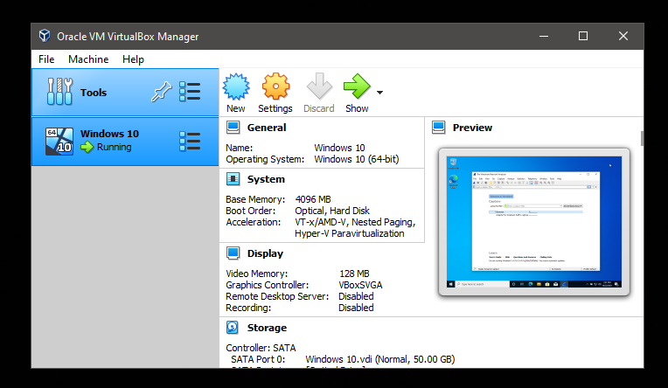

Inside the installed windows, I installed wireshark.

